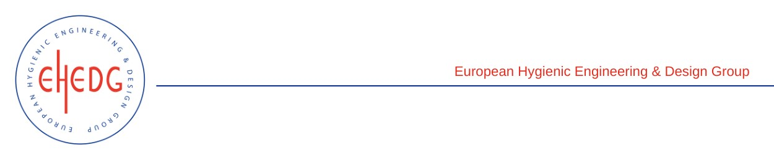

EHEDG Advanced Course on Hygienic Design

20 January, 16 & 17 February 2023
St-Malo (F-35)

Authorised trainers: Nicolas Rossi & Olivier Rondouin

Certified Attendees
CHERGUI Mahieddine

NGUEN Khoang Kyong

TANGUIDE Nelly

VEILLON Malaury

