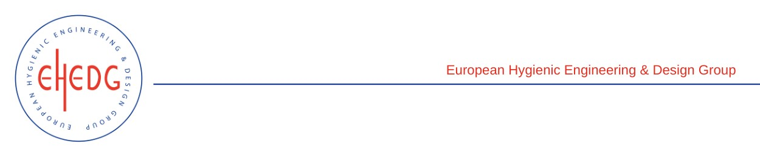

EHEDG Advanced Course on Hygienic Design

5 to 7 April 2023
Nantes, France
Authorised trainers: Nicolas Rossi & Olivier Rondouin

Certified Attendees
Flageul Thomas
Tripot Steeve
Rault Nicolas
Moreau Camille
Cesa Amélie
Gautier Alexandre
Lefebvre Eve
Lugros Lwidgi

