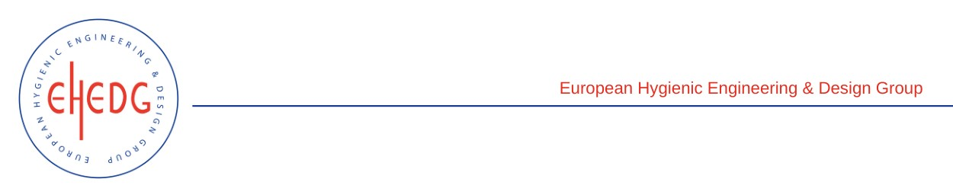

EHEDG Advanced Course on Hygienic Design

18, 19 and 25 April 2023
Courtrai, Belgium
Authorised trainers: Olivier Rondouin & Hein Timmerman

Certified Attendees
Florian Vandelle
Gauthier Pinel
François Deroubaix
Julien Atnczak

