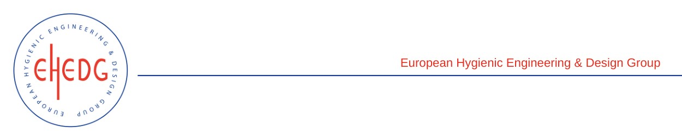

EHEDG Advanced Course on Hygienic Design

9 to 11 May 2023
Auckland, New Zealand
Authorised trainers: David Lowry & Shane Mason

Certified Attendees
Adarsh Kormath
Preeti Bhandari
Sophie Currie
Portia Tang-Wung Hsiau
Paul Koenders
Jonathan Palmer
Jiahao Wen
Joanne Theodores
Payal Lata
Charlotte Clarke
Michelle Accurso
Yang (Gary) Guo
Chia Ying
Kelly King
Dave Waite
Iain Gordon
Stephanie Gunn
Haresh Khedekar

Brendan Taylor
Michael Betschart
Reed Fisher
Kimberley Phalen
Samuel Munro

