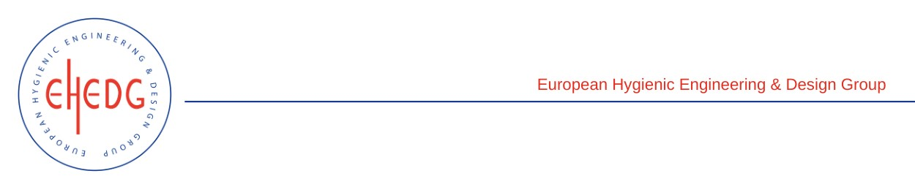

EHEDG Advanced Course on Hygienic Design

28 February to 2 March 2023
Brøndby (Denmark)

Authorised trainer: Alan Friis

Certified Attendees
Anneli Pettersson
Brian Bonnet
Paolo Corbellani
Felix Neumair
Hanna Nykvist
Lajla Bøtter-Jensen

