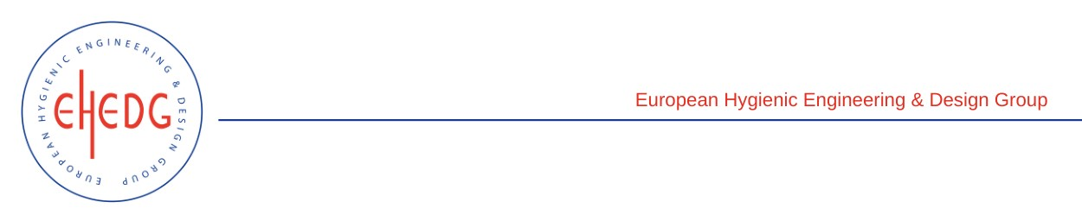

EHEDG Advanced Course on Hygienic Design

24 to 26 May 2023
Bangkok, Thailand
Authorised trainers: Navaphatra Nunak, Taweepol Suesut, Jedsada Chaichome and Worapanya Suthanuphapwut

Certified Attendees
JITTRAPA KREEPOKE
CHANITTHA JIRANANTAPART
JAKGRAPONG FUENGJIRAPRAPHAN
SONGKLOD RANGSAPROM
SHINNANIST PATHUMPONGSOTHORN
KHWANRUAN BOONKAM
PORNNARONG PEERANARONG
PICHA PANMONGKOL
PRAPAPORN THAIPRANEE
BADIN SOMLITSOPAK

